1. **What is Project Akshara?**

Project AKSHARA is a joint initiative of 100 Smiles Charity Foundation and Abhaya Foundation to completely revamp and plug infrastructural gaps in Two (2) Govt School Clusters consisting of 29 Schools of Thorrur and Bayyaram Mandals (Mahabubabad District)

1. **How you are going to develop schools in 2 clusters?**

After working in education sector for 5 years and thorough brainstorming, we have fixed few parameters that has to be present in every government school. We have divided these parameters into two stages.

|  |  |  |  |  |  |  |  |
| --- | --- | --- | --- | --- | --- | --- | --- |
| STAGE 1 | Electricity, Fans, Lights | Green Boards | Whitewash and Educational Paints | Desks and Benches | Water | Sports Material | Toilets |
| STAGE 2 | Library | Science Lab | Computer Lab | Digital Classroom | Skills  Centre | Plantation |

We will make sure our schools has all these project parameters. Apart from this, project will work to strengthen School Management Committees to maintain and sustain the facilities provided.

1. **Total how many students are getting benefited from this project?**

As initial estimates, around 3200 students from 29 schools comprising of primary, upper primary and high schools will be directly benefitted from this project. This project will also act as a model to get inspired and follow in other places.

1. **How much is the estimated budget for this project?**

Current Estimates on lower side: Rs. 53, 45, 500 (excluding compound wall, toilets)

1. **Now where are we on this project?**

We have identified 29 schools and received requirements from all schools. Currently, we are visiting schools and preparing budget estimates.

1. **What is the district administration role in this project?**

Though NGOs play a role to plug the gaps in infrastructure or outcomes, the daily and central work is always done by the government. School can only be uplifted through effective collaboration with the administration. Right from helping us in selecting the schools, motivating teachers and other stakeholders to come up with the requirements, district administration will support this project. Even after completing the project, district administartion will help the project to sustain.

1. **For what support you are looking for?**

Responsible Corporates who want to join this initiative through their funding (CSR) to make quality education accessible to all, irrespective of accident of birth.

1. **What is the need of Project Akshara?**

Telangana has around 30,000 government schools. Though some schools are good, many lack in basic infrastructure and cannot be a choice for parents when compared to private schools. As Dr. Jayaprakash Narayan puts it, "Education is a right but quality is still a dream". So, there is a need to plug both infrastructure and outcome gaps. We are plugging infrastructure gaps through this project so that teachers could concentrate on outcomes. School Management Committees will later sustain the facilities that are provided. From our experience of 5 years in working with Government schools, we have come up with this cluster based development.

1. **Apart from Corporates, how can individuals contribute to the project?**

Individuals can also donate to the NGO both for the project or otherwise. All donations towards 100 Smiles Charity Foundation are exempted from Income Tax under 80(G).

|  |  |  |  |
| --- | --- | --- | --- |
|  | Bank Transfer | Other Transfers ( Debit Card, Credit Card, UPI etc.,) / More Details | Foreign Contributions |
| 100 Smiles Charity Foundation | Account Name : 100 Smiles Charity Foundation  Account No : 6468886184  IFSC : IDIB000M180  Indian Bank, Madhapur, Hyderabad | <http://100smiles.org/#/donateUs> | -NIL- |
| Abhaya Foundation | Account Name : Abhaya FOUNDATION  Account No: 910010042902046  MICR Code: 500211002  RTGS/IFSC Code:UTIB0000008  Bank: AXIS Bank Ltd  Branch: Begumpet, Hyderabad | More Details :  <https://abhayafoundation.org/donations.aspx> | Account Name : Abhaya FOUNDATION  Account No: 052210011051007  MICR Code: 500011042  RTGS/IFSC Code:ANDB0000522  Bank: ANDHRA Bank  Branch: S.R.Nagar, Hyderabad |

Please let us know whether donation (before or after the donation) is specifically for this project or other projects

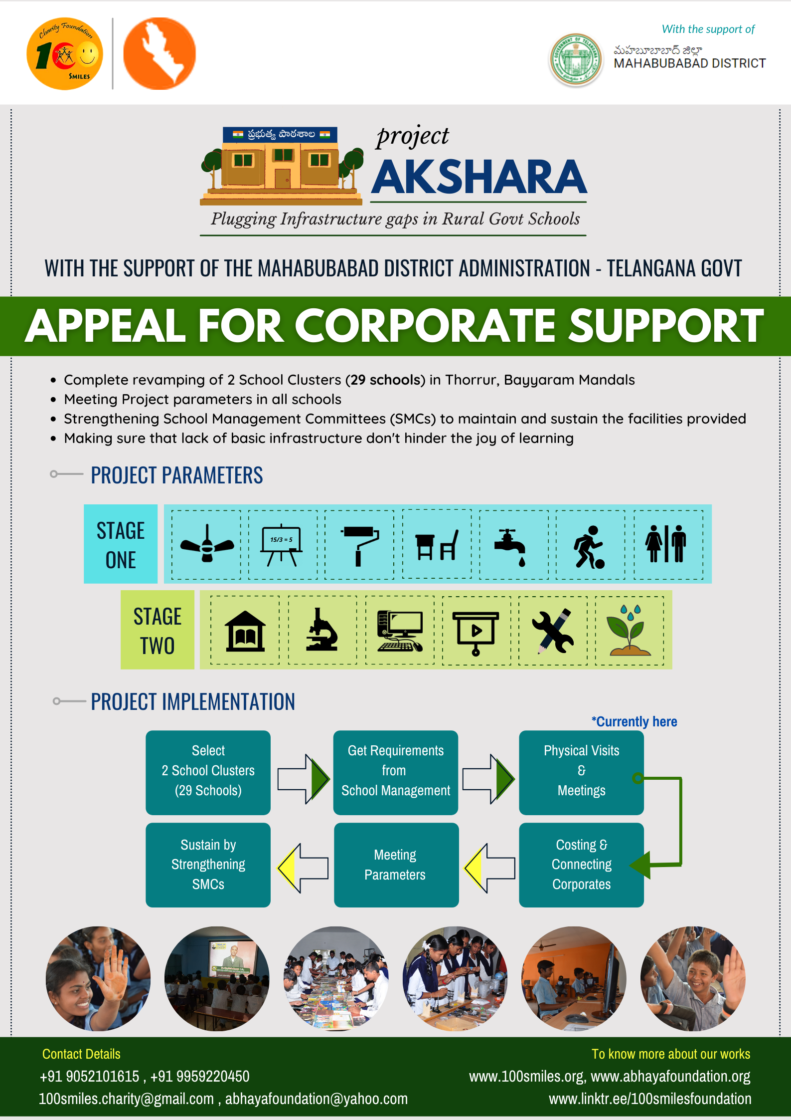

TEAM MEMBERS DISCUSSING WITH MAHABUBABAD COLLECTOR Shri V.P Gautham, DEO Shri Sharma Garu and DSO Shri Apparao in January 2021 regarding cluster wise development of government schools

